Quiz 11
- Analyze code structure: Identify the data files being used and lay out the function call hierarchy.
CreateODFStudents.m
mkODF.m
obtain_Lmax.m
construct_SH_basis.m
recon_matrix.m
plotQBI.m
polarm.m
plotVSD.m

- ODF comparison: For two different slices (same ii, jj), extract and compare ODFs.

24th slice
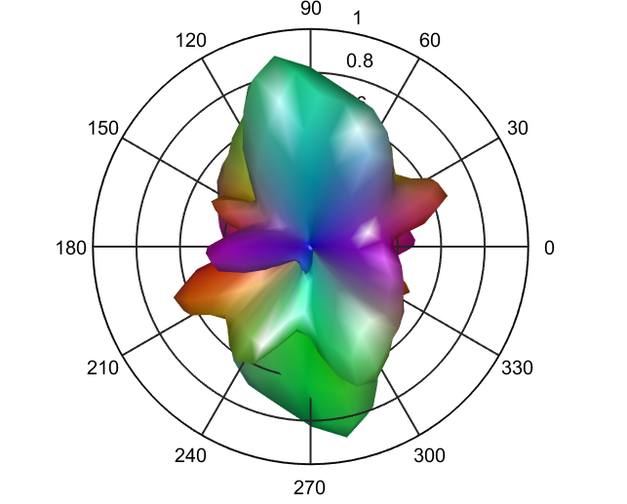

17th slice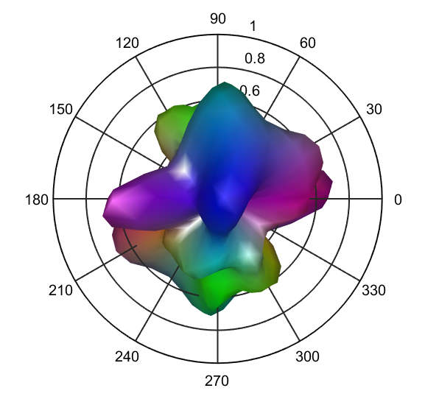

At the same indexes of the different slice, there’s a small vertical difference between the two images.

- ODF comparison: Pick one slice and draw two ODFs at two different q-balls.
ii = 23, ij = 12
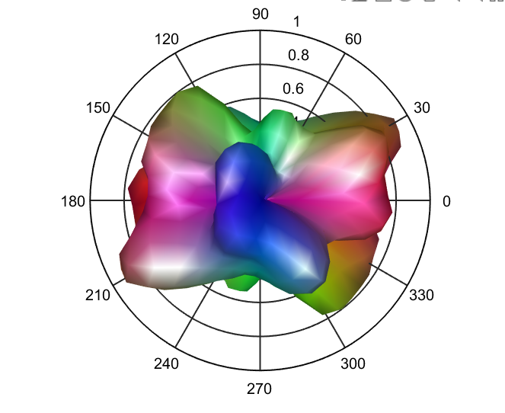

ii = 29, ij = 16
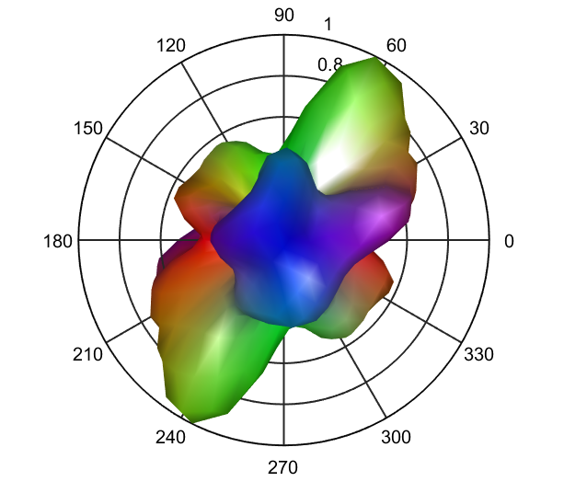

At difference indexes of the same slice, there’s much more difference to the q-ball images.
- Your ODF: Draw the ODF considering the signal at the 120 red locations you selected.

